**CISCO.** Cisco Networking Academy· Mind Wide Open

# Lab - Using a Multimeter and a Power Supply Tester

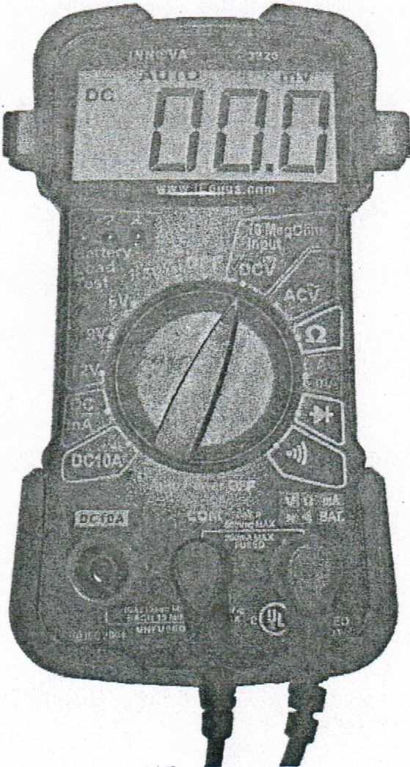

## Introduction

In this lab, you will learn how to use and handle a multimeter and a power supply tester.

## Recommended Equipment

* A digital multimeter
* The multimeter manual
* A battery to test
* A power supply tester
* A manual for the tester
* A power supply

**Note:** The multimeter is a sensitive piece of electronic test equipment. Do not drop it or handle it carelessly. Be careful not to accidentally nick or cut the red or black wires or leads, called probes. Because it is possible to check high voltages, take extra care to avoid electrical shock.

#### Lab - Using a Multimeter and a Power Supply Tester

**Part 1: Multimeter**

### Step 1: Set up the multimeter.

1. Insert the red and black leads into the jacks on the meter. The black probe should go in the COM jack and the red probe should go in the+ (plus) jack.
2. Turn on the multimeter (consult the manual if there is no ON/OFF switch). What is the model of the multimeter?

AM33D

What action must be taken to turn the meter on?

TURN RIGHT OR LEFT. WE TURNED LEFT TO 20V SETTING FOR DC POSITION.

### Step 2: Explore the different multimeter measurements.

1. Switch or turn to different measurements. For example, the multimeter can be adjusted to measure Ohms.

How many different switch positions does the multimeter have?

ONLY FIVE

What are they?

DC, AC, RESISTANCE, CURRENT, SWITCH

1. Switch or turn the multimeter to the DC voltage measurement. What symbol is shown for this?

V

### Step 3: Measure the voltage of a battery.

1. Place the battery on the table. Touch the tip of the red (positive) probe to the positive(+) side of a battery. Touch the tip of the black (negative) probe to the other end of the battery.

What is shown on the display?

12.25

If the multimeter does not display a number close to the battery voltage, check the multimeter setting to ensure it is set to measure voltage, or replace the battery with a known good battery. If the number is negative, reverse the probes.

1. Name one thing you should not do when using a multimeter.

DO NOT OVERLOAD EITHER TO THE HIGHER OR LOWER RANGE VOLT

1. Name one important function of a multimeter.

TO MEASURE THE VOLTAGE.

1. Disconnect the multimeter from the battery. Switch the multimeter to OFF. Part 1 of the lab is complete. Have your instructor verify your work.

#### Lab - Using a Multimeter and a Power Supply Tester

Why is a digital multimeter an important piece of equipment for a technician? Explain your answer.

IT IS IMPORTANT TO KNOW DIFERENTS VALUES SUCH AS VOLTAGES, RESISTANCE

**Part 2: Power Supply Tester**

Complete only the steps for the connectors supported by the power supply tester that you are using.

### Step 1: Check the testing ports for the power supply tester.

Many power supply testers have connector ports to test the following power supply connectors:

* 20-pin/24-pin motherboard connector
* 4-pin Molex connector
* 6-pin PCI-E connector
* P4 +12V connector.
* P8 +12V EPS connector
* 4-pin Berg connector
* 15-pin SATA connector

Which connectors does the power supply tester you are using have?

**20-pin/24-pin motherboard connector, 4-pin Molex connector, 6-pin PCI-E connector,**

**P8 +12V EPS connector, 4-pin Berg connector, and 15-pin SATA connector.**

### Step 2: Test the power supply motherboard connector.

Complete the following steps for the connectors supported by the power supply tester that you are using.

1. Set the power supply switch (if available) to the OFF (or 0) position.
2. Plug the 20-pin or 24-pin motherboard connector into the tester.
3. Plug the power supply into an AC outlet.
4. Set the power supply switch (if available} to the ON (or 1) position.

If the power supply is working, LEDs will illuminate and you might hear a beep. If the LED lights do not illuminate, it is possible the power supply could be damaged or the motherboard connector has failed. In this instance, you must check all connections, ensure the power supply switch (if available) is set to ON (or 1) and try again. If the LEDs still do not illuminate, consult your instructor.

Possible LED lights include +5 V, -5 V, +12 V, +5 VSB, PG, -12 V, and +3.3 V.

Which LED lights are illuminated?

3.3V,12V, PG,5VSB, 12V, 5V

### Step 3: Test the power supply Molex connector.

Plug the 4-pin Molex connector into the tester. The LED illuminates on +12 V and +5 V. (If the power output fails, the LEDs will not illuminate.)

Which LED lights are illuminated?

12V N 5V

**Lab** - **Using a Multimeter and a Power Supply Tester**

### Step 4: Test the 6-pin PCI-E connector.

Plug the 6-pin PCI-E connector into the tester. The LED will illuminate on +12 V. (If the power output fails, the LED will not illuminate.)

Does the LED light illuminate?

YES, IT DOES.

### Step 5: Test the 5-pin SATA connector.

Plug the 5-pin SATA connector into the tester. The LED will illuminate on +12 V, +5 V, and +3.3 V. (If the power output fails, the LEDs will not illuminate.)

Which LED lights are illuminated?

12V 3.3V 5V

### S_tep 6: Test the 4-pin Berg connector.

Plug the 4-pin Berg connector into the tester. The LED will illuminate on +12 V and +5 V. (If the power output fails, the LEDs will not illuminate.)

Which LED lights are illuminated?

12V N 5V

### Step 7: Test the P4/P8 connectors.

1. Plug the P4 +12 V connector into the tester. The LED will illuminate on +12 V. (If the power output fails, the LEDs will not illuminate.) **NOT AVAILABLE**
2. Plug the P8 +12 V connector into the tester. The LED will illuminate on +12 V. (If the power output fails, the LEDs will not illuminate.)

Which LED lights are illuminated?

12V

1. Switch the power supply to OFF (or 0) if available. Disconnect the power supply from the AC outlet. Disconnect the power supply from the power supply tester. The lab is complete. Have your instructor verify your work.

Why is a power supply tester an important piece of equipment for a technician? Explain your answer.

TO MEASURE DIFFENTS CABLE IN THE POWER SUPPLY AND KNOW IF THE POWER SUPPLY IS WORKING PROPERLY.



**Investigate BIOS or UEFI Settings**

**Enter BIOS or UEFI.**

What is the key or combination of keys used to enter the firmware setup utility program?

F2 OR F12 AND THEN WE CHOOSE ENTER SETUP

Who manufactures the BIOS or UEFI system for your computer?

UEFI

What is the BIOS or UEFI version?

A16

**Explore the Settings.**

List the main menu options and describe what is monitored in each menu?

GENERAL, SYSTEM CONFIGURATION, VIDEO, SECURITY, PERFORMANCE, POWER MANAGEMENT, POST BEHAVIOR, VIRTUALIZATION SUPPORT, MAINTENANCE, SYSTEM LOGS

What security settings and features are available?

Admin Password, System Password, Internal HDD-0 Password, Strong Password, Password Configuration,

Password Bypass, Password Change, TPM Security, Computrace(R), Chassis Intrusion, CPU XD Support,

OROM Keyboard Access, Signed Firmware Update, and Admin Setup Lockout.

What is the CPU speed?

3.1O GHz

What other information is listed for the RAM?

Memory Installed= 8192 MB, Memory Available= 8152 MB, Memory Speed= 1333 MHz, Memory Channel Mode = Dual InterLeave,

Memory Technology= DDR3 SDRAM, DIMM 1 Size= 2048 MB, DIMM 2 Size= 2048 MB,DIMM 3 Size= 2048 MB,

DIMM 4 Size= 2048 MB

What information is listed for the hard drive?

SATA-0

Type =240 GB HDD, Device ID= OCZ-AGILITY3

What is the first boot device in the boot order sequence?

Diskette drive

How many additional devices can be assigned in the boot order sequence?

5 devices

Why would you change the first boot device to the optical drive?

Because the optical drive can have an operate system that we can use as bootable media

What happens when the computer boots and the optical drive does not contain bootable media?

The system boot sequence takes the next in the list

What power management settings are available?

AC Recovery, Auto On Time, Deep Sleep Control, Fan Control Override, and Wake on LAN

What PnP settings are available?

Not available

What splash screen settings are available?

Not available



**Search for BIOS or UEFI Firmware Updates using the internet.**

* What key or combination of keys is used to run Setup on your computer?

F2 OR F12 AND THEN WE CHOOSE ENTER SETUP

* Who is the manufacturer of the BIOS?

Dell Inc.

* Which BIOS version is installed in your computer?

A16

* What is the current BIOS version available for the motherboard?

A21

* What features, if any, have been added to the new BIOS version?

The new bios improve functionality, reliability, and stability of your Dell system.

* What changes, if any, have been made to the new BIOS version to fix problems?

Critical bug, security fixes and other feature enhancements.

* What are the instructions to update the new BIOS version?

Note 1. Before updating the BIOS, ensure that you suspend BitLocker encryption on a BitLocker-enabled system. If BitLocker is not enabled on your system, you can ignore this step

Note 2: Do not turn off power or interrupt the BIOS update process during the update.  
Note 3: Your system requires a restart after installing the BIOS. The restart can be deferred but must be completed to ensure that the update is installed.

Updating the BIOS from Windows

Download and Installation  
1. Click Download File.  
2. Click Save to save the file to your hard drive.  
3. Browse to the location where you downloaded the file.  
4. Double-click the new file.  
5. The system restarts automatically and updates the BIOS at the system startup screen. After the BIOS update is complete, system restarts again.

Updating the BIOS from DOS (Non-Windows users)

Installation  
Note: You must provide a bootable USB drive. This executable file does not create the DOS system files.  
1. Copy the downloaded file to a bootable USB drive.  
2. Power on the system and then Press the F12 key.  
3. Select USB Storage Device and boot to the DOS prompt.  
4. Run the file by typing following command. For example:  
C:\ Precision_T1600_X.Y.Z.exe  
Where C is the drive letter of the USB device where the executable file is located and Precision_T1600_X.Y.Z.exe is the name of the downloaded file.  
The system restarts automatically and updates the BIOS at the system startup screen. After the BIOS update is complete, system restarts again.

Updating the BIOS from DOS with UEFI boot mode enabled (Non-Windows users, Load Legacy Option Disabled)

Installation  
1. Copy the downloaded file to a bootable DOS USB drive.  
2. Power on the system and then go to BIOS Setup by pressing the F2 key.  
3. Go to General > Boot Sequence > Boot > Boot List Option.  
4. Change UEFI to Legacy of Boot List Option.  
5. Go to Exit > Save Changes and reboot system.  
6. Press F12 and then select USB Storage Device and boot to the DOS prompt.  
7. Run the file by typing the file name.  
8. The system restarts automatically and updates the BIOS at the system startup screen. After the BIOS update is complete, the system restarts again.  
9. Go to BIOS Setup by pressing the F2 key and go to General > Boot Sequence > Boot > Boot List Option.  
10. Change Legacy to UEFI Boot Option.  
11. Go to Exit > Save Changes and reboot the system.